Population pharmacokinetics of continuous infusion ampicillin in the treatment of enterococcal infections in adult hospitalised patients

Carla Troisi¹, Pier Giorgio Cojutti², Linda Bussini³, Elena Rosselli Del Turco³, Maddalena Giannella^{1,3} and Federico Pea^{1,2}
1. Department of Medical and Surgical Sciences, Alma Mater Studiorum, University of Bologna, Bologna, Italy
2. Clinical Pharmacology Unit, IRCCS Azienda Ospedaliero Universitaria di Bologna, Bologna, Italy
3. Infectious Diseases Unit, IRCCS Azienda Ospedaliero-Universitaria di Bologna, Bologna, Italy

Acknowledgement:
This project has received funding from European Union’s Horizon 2020 research and innovation program under the Marie Sklodowska-Curie grant agreement No 861323.
Introduction/Objectives:
Enterococci are one of the most common causes of hospital-associated infections, with a prevalence rate of 9.7% (1). They are associated with mortality rates as high as 14.3–32.3% (1). According to the IDSA guidelines, enterococcal infections should be treated with a combination therapy including ampicillin as backbone (2).
Similar to all the other beta-lactam drugs, ampicillin demonstrates a time-dependent antibacterial killing. In order to maximize the time during which the plasma concentration is maintained above the MIC of the pathogen (T>MIC) (3), administration by means of 24-h continuous infusion (CI) may be applied (4).
The population pharmacokinetics of CI ampicillin has never been described in patients with enterococcal infections. The aim of this study is to describe the population pharmacokinetics of CI ampicillin in a cohort of hospitalized patients with enterococcal infections.
Methods:
This retrospective study was conducted among patients who were treated with a combination therapy including 24h-CI ampicillin for enterococcal infections at the IRCCS Azienda Ospedaliero-Universitaria di Bologna, Bologna, Italy in the period Aug 2021 – Mar 2022. Due to stability restrictions, 24h-CI was granted by reconstituting each ampicillin aqueous solution every 6h and by infusing it over 6h. Therapeutic drug monitoring (TDM) of ampicillin steady-state concentration (Css) was applied for dose adjustments. Demographics and clinical data (ampicillin dose, co-treatments, serum creatinine) were retrieved from medical records. Creatinine clearance (CL_{CR}) was estimated by means of the CKD-EPI formula.
Since only Css data were available, a one-compartment population pharmacokinetic model with first-order elimination was implemented in Monolix (version 2021R1, Lixoft). A proportional error model was used in the base model. Covariate analysis was performed and any covariate was retained in the final model only if decreases of the Akaike information criteria (AIC), of the Bayesian information criteria (BIC) and of the objective function value (OFV) of ≥3.84 were observed compared to the base model. Model performances were assessed by means of regression analysis of observed values compared with either population predictions or individual predictions, the distribution of the weighted residuals and the visual predictive check (VPC) plot.
Results:
Twelve patients (7 males, 58%) with mean (SD) age and weight of 71.0 (8.1) years and 67.6 (15.1) kg, respectively, were included. All but one patient had bloodstream infections (11/12, 91.7%), and the remaining one had complicated urinary tract infection (1/12, 8.3%). Enterococcus faecalis was isolated in 11/12 (91.7%) subjects, while Enterococcus casseliflavus in the remaining patient (1/12, 8.3%). Ampicillin was co-administered with ceftriaxone in 11/12 patients (91.7%) and with ertapenem in 1 patient (1/12, 8.3%). Median (IQR) ampicillin dosage, Css and duration of therapy were 4 (2-8) g, 49.0 (21.9-81.2) mg/L, and 12.5 (9.5-20.3) days, respectively. Median (IQR) CL_{CR} was 48.0 (24.0-65.5) mL/min/1.73m².
Overall, 49 ampicillin Css were used to build the population pharmacokinetic model. The one-compartmental model adequately fitted the data. The observation-vs.-population and observation- vs.-individual predicted concentrations yielded a R² of 0.6824 and 0.9515, respectively (Fig. 1A). There was no evident trend in the distribution of residuals (Fig. 1B). The VPC showed that the medians of the observations were comprised within the 5°-95° percentiles of the prediction bands (Fig. 1C). Ampicillin CL and Vd were of 3.92 L/h (SE 1.06, RSE 27.1 %) and 80.72 L (SE 68.07, RSE 84.30%), respectively.
Serum creatinine and BMI resulted as significant covariates on drug CL (OFV reduced from 392.53 to 378.03, AIC from 402.53 to 394.03 and BIC from 404.95 to 397.0).
Discussion/Conclusion:
This is the first population PK model of CI ampicillin in enterococcal infections. Our model gave CL estimates quite similar to those obtained in the literature, specifically in Japanese patients treated with ampicillin-sulbactam for community acquired pneumonia (6) and in patients with prostatic hyperplasia (7) (CL of 10.7 and 11.03 L/h, respectively). Even if limited by the small sample size, the model adequately fitted the data and may be considered reliable for simulation analysis.

References:
1. Brinkwirth S, Ayobami O, Eckmanns T, Markwart R. Hospital-acquired infections caused by enterococci: a systematic review and meta-analysis, WHO European Region, 1 January 2010 to 4 February 2020. Euro Surveill Bull Eur Sur Mal Transm Eur Commun Dis Bull. nov 2021;26(45).
2. Infective Endocarditis in Adults: Diagnosis, Antimicrobial Therapy, and Management of Complications: A Scientific Statement for Healthcare Professionals From the American Heart Association - PubMed [Internet]. [cité 6 avr 2022]. Disponible sur: https://pubmed.ncbi.nlm.nih.gov/26373316/
3. MacGowan A. Revisiting Beta-lactams – PK/PD improves dosing of old antibiotics. Curr Opin Pharmacol. 1 oct 2011;11(5):470‑6.
4. Ogawa T, Kasahara K, Ikawa K, Shigeta J, Komatsu Y, Kuruno N, et al. Continuous ampicillin infusion as an alternative to intermittent infusion for adult inpatients: a case series. J Infect Chemother Off J Jpn Soc Chemother. oct 2014;20(10):653‑5.
5. Humans IWG on the E of CR to. Ampicillin [Internet]. Pharmaceutical Drugs. International Agency for Research on Cancer; 1990 [cité 6 avr 2022]. Disponible sur: https://www.ncbi.nlm.nih.gov/books/NBK526244/
6. Soto E, Shoji S, Muto C, Tomono Y, Marshall S. Population pharmacokinetics of ampicillin and sulbactam in patients with community-acquired pneumonia: evaluation of the impact of renal impairment. Br J Clin Pharmacol. 2014;77(3):509‑21.
7. Onita T, Ikawa K, Nakamura K, Nishikawa G, Kobayashi I, Ishihara N, et al. Prostatic Pharmacokinetic/Pharmacodynamic Evaluation of Ampicillin-Sulbactam for Bacterial Prostatitis and

Figure. Diagnostic plots of the observations vs. population predictions and observations vs. individual predictions (panel A), residuals distribution (panel B) and visual predictive check (panel C)

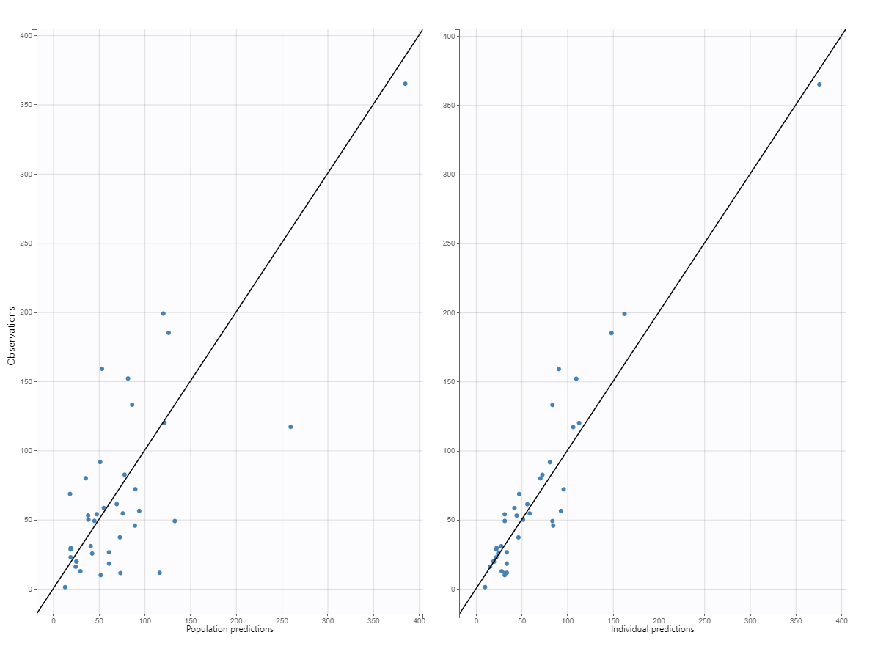
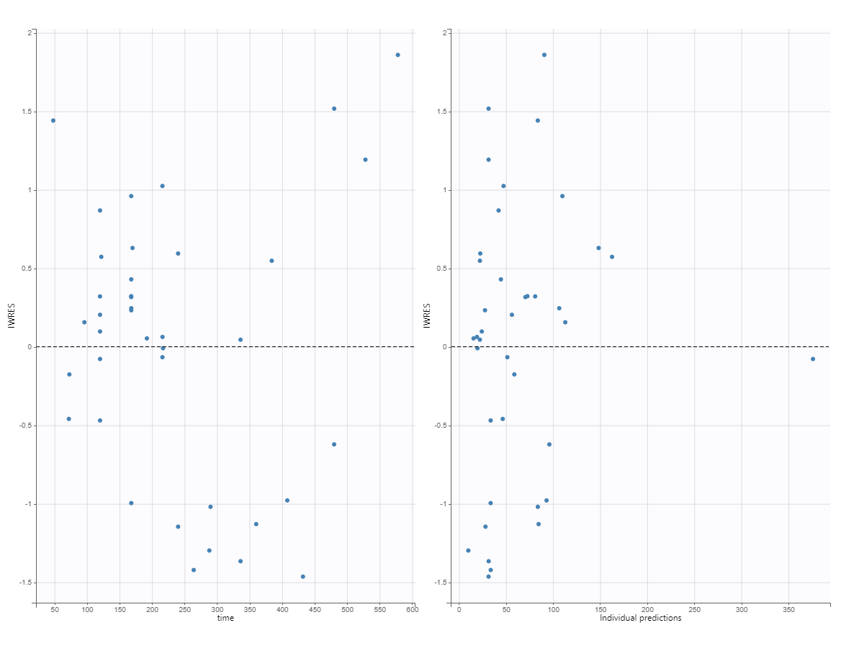
A
B
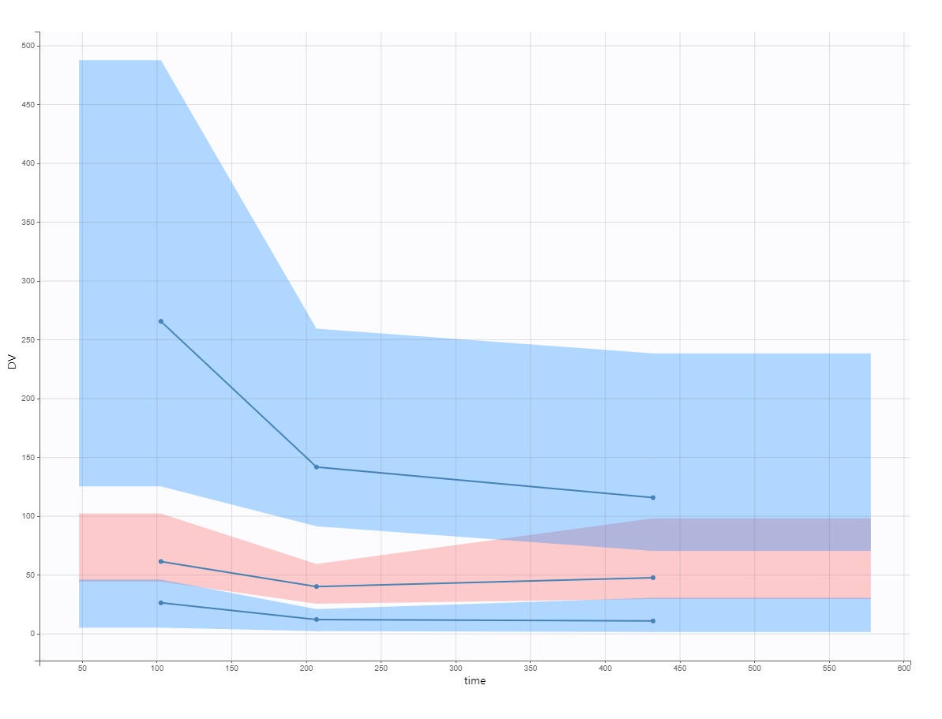
C
cC
c

